**2023 Public Power Week Graphics and Messages**

5 total - Right click each file and click “Save as Picture.”

Be sure to tag @HeartlandPower on Twitter and @HeartlandEnergySD on Facebook

Message: Join us as we celebrate #PublicPowerWeek—a celebration of YOU, our customers! Because here in [*community* *name*], we are #CommunityPowered. #PublicPower

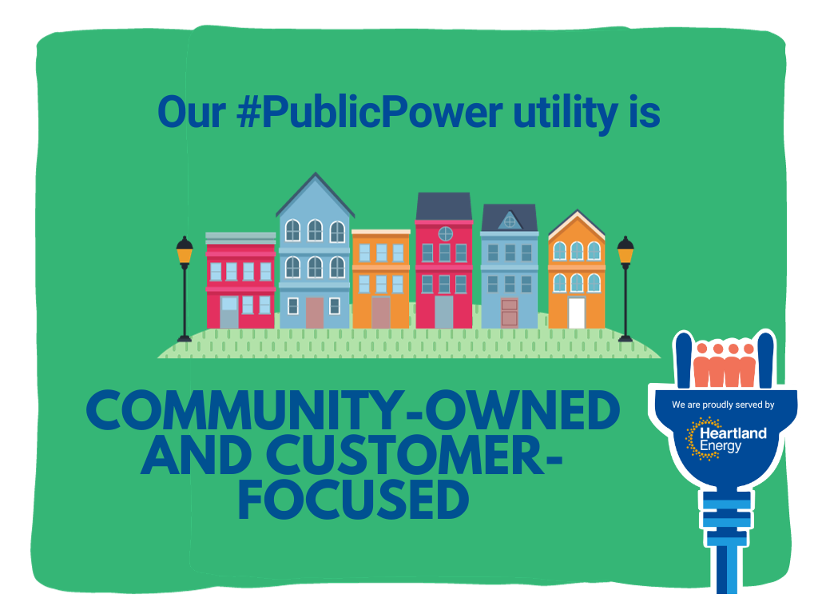

Message: Our #PublicPower utility is community-owned and customer-focused. We pay attention to what matters most: YOU. #CommunityPowered #PublicPowerWeek

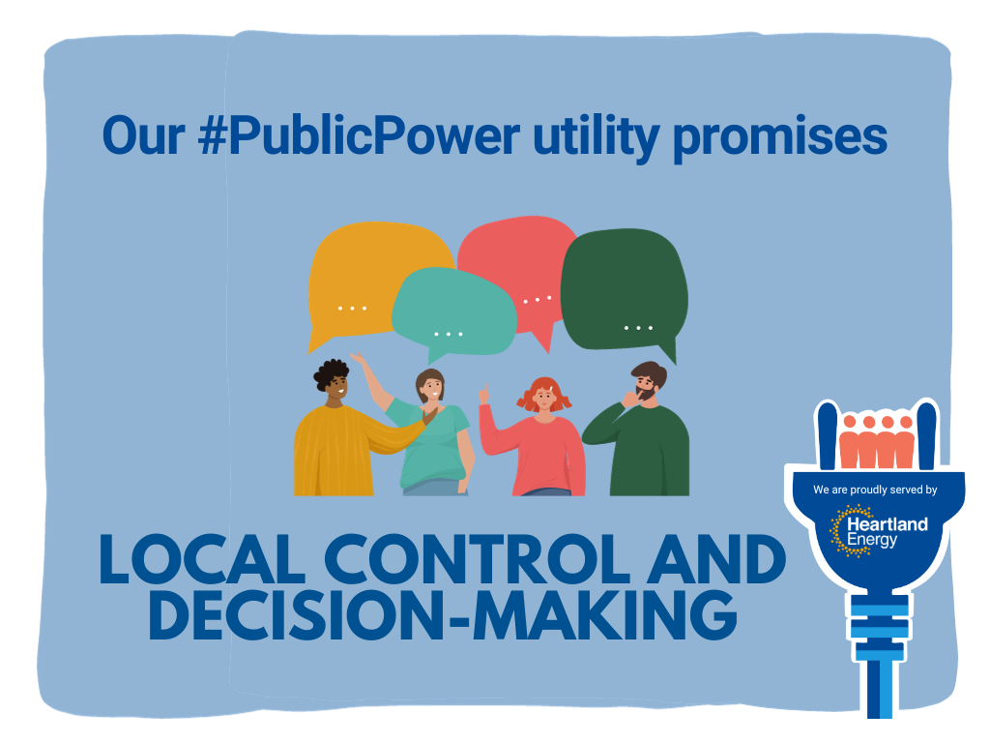

Message: With local control and decision-making, you can make your voice heard. Our #PublicPower utility promises: YOUR VOICE MATTERS. #CommunityPowered #PublicPowerWeek

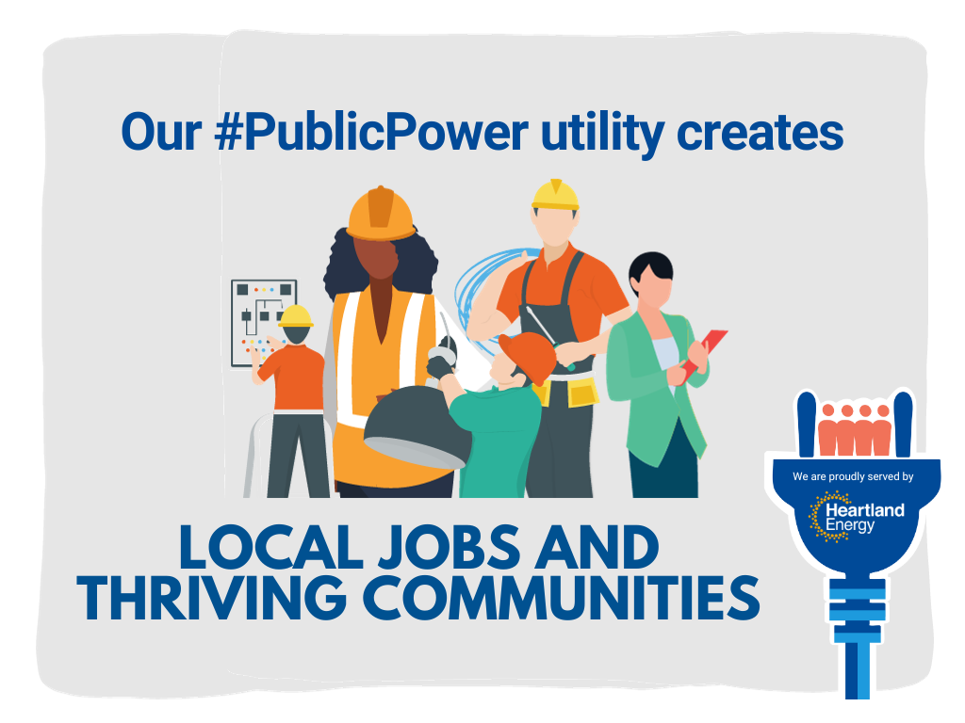

Message: #PublicPower utilities support local commerce and create jobs. We reinvest electric revenue back into the community to help residents and businesses grow and thrive. #PublicPowerWeek

Message: What are the perks of community-owned #PublicPower? Fewer outages, lower bills and quality service—a lot to celebrate this #PublicPowerWeek! #CommunityPowered